Please note the following changes to the Monthly Food Orders for Brigden Public School.

- ALL food orders MUST be completed through School Cash Online. No paper orders will be accepted.
- If you have not already done so, follow the attached instructions for creating your account with School Cash Online. Please call Brigden Public School for the student number of your child 519-864-1125.
- Keep a copy (electronic or paper) of your child’s order for your reference.

January 2019 options available to be ordered online only:
Milk Options for January ($1.00 per carton)
Every day Chocolate or White Milk (15 days)
Friday only Chocolate or White Milk (3 days)
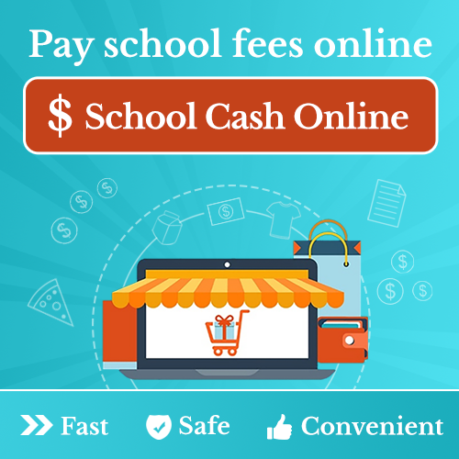
Pizza Options for Friday, January 11 ($2.50 per slice)
- Pepperoni
- Cheese
- Garlic

Variety Options for Friday, January 18 ($6.00 per sub)
- Ham
- Turkey
- Chicken
- Chicken Fingers & Vegetable Sticks
- Spaghetti & Garlic Toast

Lunch Options for Friday, January 26
- Hot Dog ($1.50 each)
- Air Caramel, dill pickle, white cheddar popcorn ($2.00 per bag)

Payments are due online by Wednesday, December 19th
To set up an account, visit: https://lkdsb.schoolcashonline.com/
Please call Brigden Public School for the student number of your child.
519-864-1125

